|  |  |
| --- | --- |
| Assignment Date | 14 September 2022 |
| Student Name | Prajwel Anandkumar |
| Student Roll Number | 2019504044 |
| Maximum Marks | 2 Marks |

**ASSIGNMENT-1**

**SMART HOME AUTOMATION**

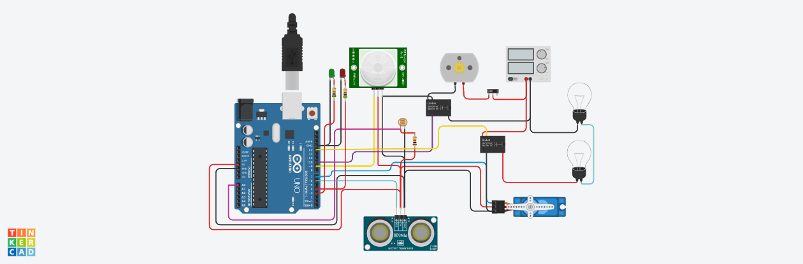

**Source code:**

|  |
| --- |
|  |
|  | #include <Servo.h> |
|  | int output1Value = 0; |
|  | int sen1Value = 0; |
|  | int sen2Value = 0; |
|  | int const LDR = A0; |
|  |  |
|  |  |
|  | long readUltrasonicDistance(int triggerPin, int echoPin) |
|  | { |
|  | pinMode(triggerPin, OUTPUT); // Clear the trigger |
|  | digitalWrite(triggerPin, LOW); |
|  | delayMicroseconds(2); |
|  | // Sets the trigger pin to HIGH state for 10 microseconds |
|  | digitalWrite(triggerPin, HIGH); |
|  | delayMicroseconds(10); |
|  | digitalWrite(triggerPin, LOW); |
|  | pinMode(echoPin, INPUT); |
|  | // Reads the echo pin, and returns the sound wave travel time in microseconds |
|  | return pulseIn(echoPin, HIGH); |
|  | } |
|  |  |
|  | Servo servo_7; |
|  |  |
|  | void setup() |
|  | { |
|  | Serial.begin(9600); //initialize serial communication |
|  | pinMode(A0, INPUT); //LDR |
|  | pinMode(A1,INPUT); //gas sensor |
|  | pinMode(13, OUTPUT); //connected to relay |
|  | servo_7.attach(7, 500, 2500); //servo motor |
|  |  |
|  | pinMode(8,OUTPUT); //signal to piezo buzzer |
|  | pinMode(9, INPUT); //signal to PIR |
|  | pinMode(10, OUTPUT); //signal to npn as switch |
|  | pinMode(4, OUTPUT); //Red LED |
|  | pinMode(3, OUTPUT); //Green LED |
|  |  |
|  | } |
|  |  |
|  | void loop() |
|  | { |
|  | //-------------------------------------------------------------- |
|  | //------light intensity control------// |
|  | //-------------------------------------------------------------- |
|  | int val1 = analogRead(LDR); |
|  | if (val1 < 500) |
|  | { |
|  | digitalWrite(13, LOW); |
|  | Serial.print("Bulb OFF = "); |
|  | Serial.print(val1); |
|  | } |
|  | else |
|  | { |
|  | digitalWrite(13, HIGH); |
|  | Serial.print("Bulb ON = "); |
|  | Serial.print(val1); |
|  | } |
|  |  |
|  | //-------------------------------------------------------------- |
|  | //------ light & fan control --------// |
|  | //-------------------------------------------------------------- |
|  | sen2Value = digitalRead(9); |
|  | if (sen2Value == 0) |
|  | { |
|  | digitalWrite(10, LOW); //npn as switch OFF |
|  | digitalWrite(4, HIGH); // Red LED ON,indicating no motion |
|  | digitalWrite(3, LOW); //Green LED OFF, since no Motion detected |
|  | Serial.print(" || NO Motion Detected " ); |
|  | } |
|  |  |
|  | if (sen2Value == 1) |
|  | { |
|  | digitalWrite(10, HIGH);//npn as switch ON |
|  | delay(3000); |
|  | digitalWrite(4, LOW); // RED LED OFF |
|  | digitalWrite(3, HIGH);//GREEN LED ON , indicating motion detected |
|  | Serial.print(" || Motion Detected! " ); |
|  | } |
|  | delay(300); |
|  |  |
|  | //-------------------------------------------------------------- |
|  | //------- servo motor ---------// |
|  | //------------------------------------------------------------- |
|  | sen1Value = 0.01723 * readUltrasonicDistance(6, 6); |
|  |  |
|  | if (sen1Value < 100) |
|  | { |
|  | servo_7.write(90); |
|  | Serial.print(" || Door Open! ; Distance = "); |
|  | Serial.print(sen1Value); |
|  | Serial.print("\n"); |
|  |  |
|  | } |
|  | else |
|  | { |
|  | servo_7.write(0); |
|  | Serial.print(" || Door Closed! ; Distance = "); |
|  | Serial.print(sen1Value); |
|  | Serial.print("\n"); |
|  | } |
|  | delay(10); // Delay a little bit to improve simulation performance |
|  | } |